AASHTO STANDING COMMITTEE ON RESEARCH
AMERICAN ASSOCIATION OF STATE HIGHWAY AND TRANSPORTATION OFFICIALS

NCHRP Problem Statement Outline

I. PROBLEM NUMBER

To be assigned by NCHRP staff.

II. PROBLEM TITLE

How Thermal Compatibility Influences the Long-Term Durability of Polymer Resin Binder Systems for High Friction Surface Treatment (HFST) and Thin-bonded Polymer Bridge Deck Overlay Systems

III. RESEARCH PROBLEM STATEMENT

Premature failure of both high friction surface treatment (HFST) and thin-bonded polymer overlay systems can be caused by thermal incompatibility with existing concrete and asphalt surfaces. These resin-rich overlay systems have a coefficient of thermal expansion (CTE) up to five times greater than the substrates they are bonded to, resulting in large internal stresses with changing temperatures. (2016, Bryan T. Wilson and Dr. Anol Mukhopadhyay). Thermal failures are manifest as debonding and delamination when the overlay bond is insufficient, and are manifest as substrate fracture and tearing when the substrate tensile strength is too weak.

One approach to mitigating these problems is to adjust the specified material properties of the polymer resin. A more flexible and forgiving polymer resin would help reduce thermal stresses. At the same time, the strength of the resin must still be adequate to resist shearing and retain aggregate under severe traffic conditions and high ambient temperatures. Therefore, there is a need to reassess the material requirements of the polymer-resin to reduce thermal stress while maintaining performance under severe traffic and climate conditions.

Special note to AASHTO Committees and Subcommittees: Please indicate the relationship between the suggested problem and the committee’s strategic plan and/or its overall research agenda.

Technical Section 4c is the owner of PP 79-14(2016) High-Friction Surface Treatments for Asphalt and Concrete Pavements which treatments are similar to Bridge Deck sealing overlays. This research will help better define the interaction between the target surface material and the treatment materials due to climatic temperature variation and potentially provide guidance for the standard and specifications to address this interaction.

Advice to State Departments of Transportation and the Federal Highway Administration: Submitters are encouraged, but not required, to vet or submit problem statements through an appropriate AASHTO committee or subcommittee.

IV. LITERATURE SEARCH SUMMARY

Three studies were found in a search that were related to HFST and Bridge Polymer overlay performance, however none addressed specifically the issue of thermal characteristics of the target surface and the treatment material though the Florida DOT/FHWA Report BDR74-977-05 did explore this issue to some degree.

The studies were:

1) Performance of Concrete Bridge Deck Surface Treatments
Prepared for Utah Department of Transportation
Authors: W. Spencer Guthrie, Ph.D., Tyler Nelsen, EIT, and Loren A. Ross of Brigham Young University
Date: May 2005
Report No.: UT-05.05

2) Alternative Aggregates and Materials for High Friction Surface Treatments
Prepared for Florida Department of Transportation and FHWA
Authors: Bryan Wilson and Anol Mukhopadhyay, Ph. D. of Texas A&M
Date: May 2016
Project No.: BDR74-977-05

3) Evaluation of Thin Polymer Overlays for Bridge Decks
Prepared for Wisconsin Department of Transportation
Authors: Habib Tabatabai, Konstantin Sobolev, Al Ghorbanpoor, Azam Nabiazdeh, Chin-Wei Lee, and Matthias Lind of University of Wisconsin-Milwaukee
Date: July 2016
Report No.: Wisconsin DOT ID 0092-12-06

V. RESEARCH OBJECTIVE

Determine material properties for the resin binder system that will mitigate issues with thermal incompatibility while maintaining a good bond, resisting shearing, and retaining aggregate under severe traffic and conditions, even at high service temperatures. These specific properties are under consideration: tensile strength, tensile elongation, compressive modulus, bond strength, and glass transition temperature. The desired outcome of this study is an eventual modification of the specified resin binder properties.

- Utilize CTE properties and calculate stresses at the bond interface. Consider the viscoelastic nature of the materials. Substrate properties for testing/modeling purposes should be representative and include worst/best scenarios based on aged asphalt pavements with low tensile properties to new, fully hydrated, high strength concrete.
- Using performance tests and/or modeling, determine the critical resin binder system requirements to remain bonded, resist shearing, and retain aggregate under severe traffic and climate conditions. The primary traffic scenario in question is turning movements around tight horizontal curves. Decelerating/accelerating intersection traffic could also be considered. For the climate condition, consider high ambient service temperatures.
- Based on findings, recommend modifications to existing ASTM test standards and/or similar. Consider the following methods as appropriate:

  - Tensile Strength and Tensile Elongation Test Method (ASTM D-638)
  - Glass Transition Temperature (Tg) Test Method (ASTM E-1640)
  - Adhesive properties Test Method (ASTM C-1583)
  - Compressive Modulus Test Method (ASTM D-695)

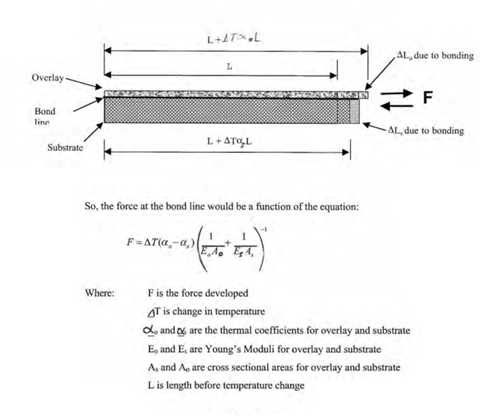

VI. ESTIMATE OF PROBLEM FUNDING AND RESEARCH PERIOD

Recommended Funding:

$80,000.00

(Note: The level of funded provided may be raised or lowered by the AASHTO Standing Committee on Research if and when the problem statement is selected)

Research Period:

(Note: This estimate may be changed by the Project Panel.)

VII. URGENCY AND POTENTIAL BENEFITS

The goal is to propose new resin binder property requirements that minimize tensile strains caused by thermal incompatibility by lowering tensile strength, compressive modulus, and increase tensile elongation without shearing and losing aggregate in severe service conditions. Under the current specifications, these systems are prone to premature thermal incompatibility failure because of debonding, delamination, or substrate failure. There are many studies that correlate the early age failure of thin polymer overlay and HFST systems with the relationship between substrate condition and thermal cycling (W. Spencer Guthrie, Ph.D. Tyler Nelsen, E.I.T. Loren A. Ross, 2005; Nuno Gama 1999; Sprinkel; Bryan T. Wilson and Dr. Anol Mukhopadhyay 2016; Jennifer Harper, PE 2007). It can be considered that any form of de-bonding and/or delamination of these resin based systems can be attributed at some level to thermal incompatibility. If the research is successful and implemented, the occurrence of these failures should be substantially reduced.

VIII. IMPLEMENTATION PLANNING

HFST and Polymer Overlay for Bridge Deck users and supporting industry would benefit from this research. Potential immediate specifying conditions for AASHTO standard and DOT’s specifications.

IX. PERSON(S) DEVELOPING THE PROBLEM STATEMENT

Gregg Freeman
Kwik Bond Polymers
923 Teal Drive
Benicia, CA 94510
Director of Business Development
720-626-6643
gregg@kwikbonpolymers.com

X. AASHTO MONITOR

For each project selected for the NCHRP, an AASHTO Monitor will be assigned to help ensure that the research meets the needs of state DOTs and to facilitate implementation of the results. The AASHTO Monitor should be an employee of a state DOT, and typically will have been one of the authors of the problem statement. The AASHTO Monitor will be assigned by staff, but if you wish to nominate an individual for this role, please provide their specifics (name, title, affiliation, address, telephone number, e-mail address).

XI. SUBMITTED BY

Scott Andrus
UDOT State Materials Engineer/SOM TS 4c Research Liaison
scottandrus@utah.gov

Please submit completed problem statement at:

http://bit.ly/NCHRP2018Submittal

Questions on the process can be directed to chedges@nas.edu.

